Dear Patient,
Many thanks for agreeing to take part in this survey to help us understand how our Practice performs and if there are any areas that we may be able to improve on.
Number of Responses:70

Appointments.
Q1. When did you last see a Doctor at the GP Surgery?
In the past 3months 80%
Between 3 and 6 months ago 19%
More than 6months ago 1%
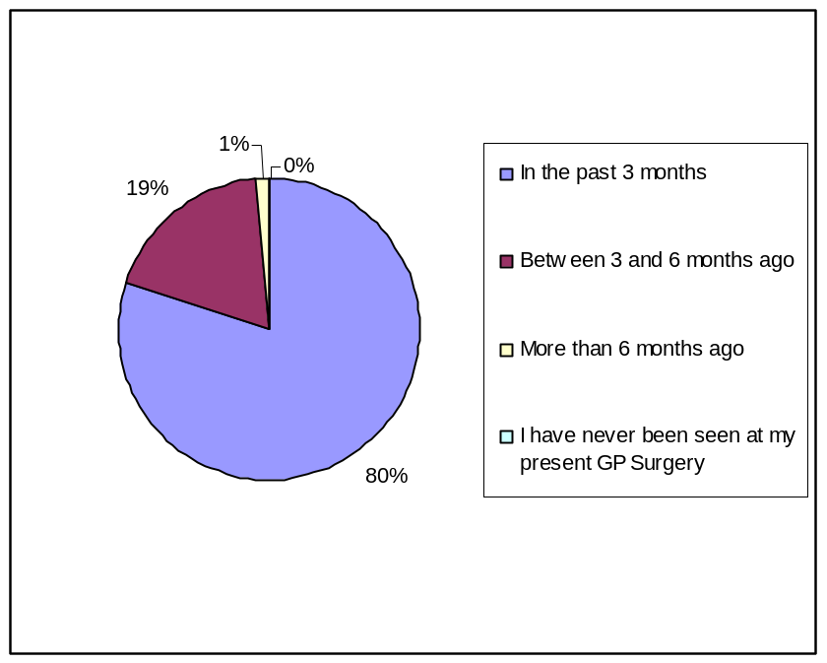
I have never been seen at my present GP Surgery 0%

Q2. If you haven’t seen a doctor in the past 6 months, why is that?
I haven’t needed to see a doctor 86%
I couldn’t be seen at a convenient time 0%
I couldn’t get to my appointment easily 0%
I didn’t like or trust the doctors 0%
Another reason 14%
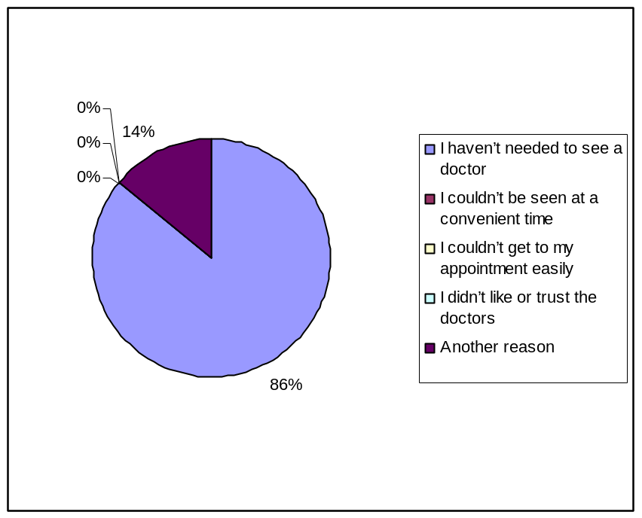

Q3. How do you normally book your appointments to see a doctor or nurse at the Surgery?
In person 38%
By Phone 59%
Online 3%
Digital TV 0%
No preference 0%
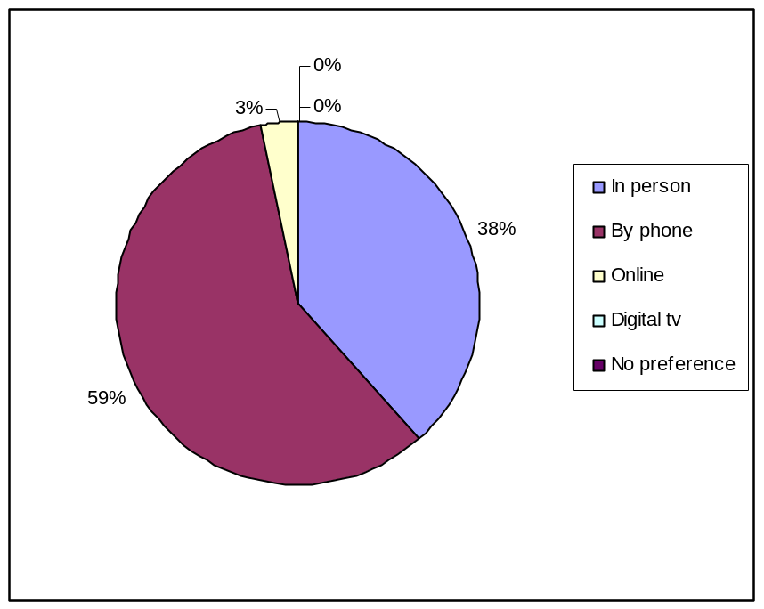

Q4. Which of the following methods would you prefer to use to book an appointment at the Surgery?
In person 18%
By phone 51%
Online 30%
Digital TV 0%
No preference 1%
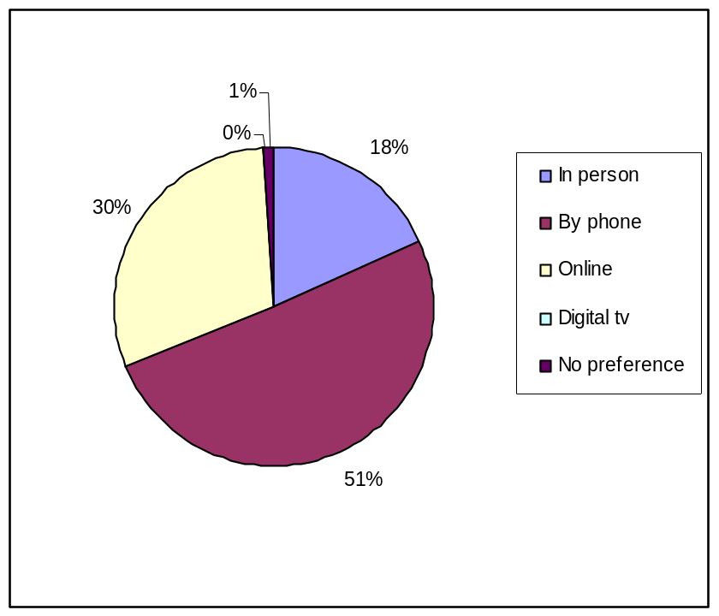

Getting through on the phone.
Q5. In the past 6 months how easy have you found the following?
- Getting through on the phone
Haven’t tried 4%
Very easy 32%
Fairly easy 35%
Not very easy 26%
Not at all easy 3%
Don’t know 0%
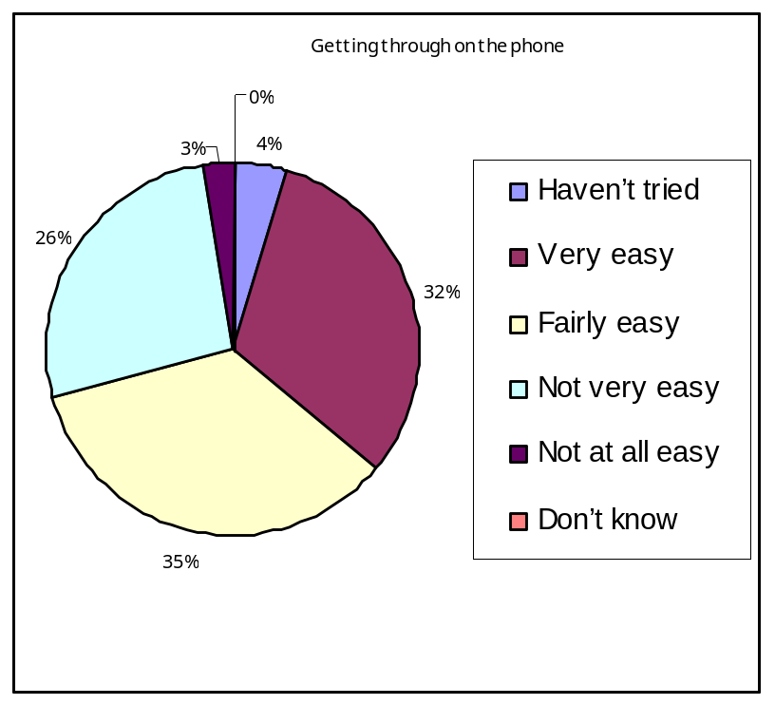

- Speaking to a Doctor on the phone
Haven’t tried 49%
Very easy 14%
Fairly easy 13%
Not very easy 4%
Not at all easy 1%
Don’t know 19%
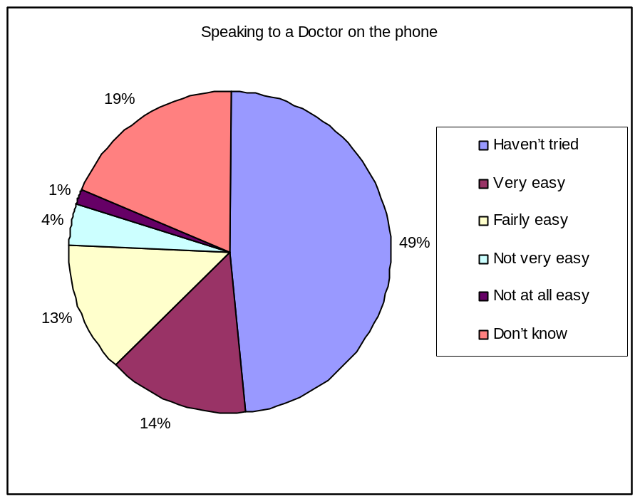

- Speaking to a Nurse on the phone
Haven’t tried 57%
Very easy 12%
Fairly easy 12%
Not very easy 1%
Not at all easy 0%
Don’t know 18%
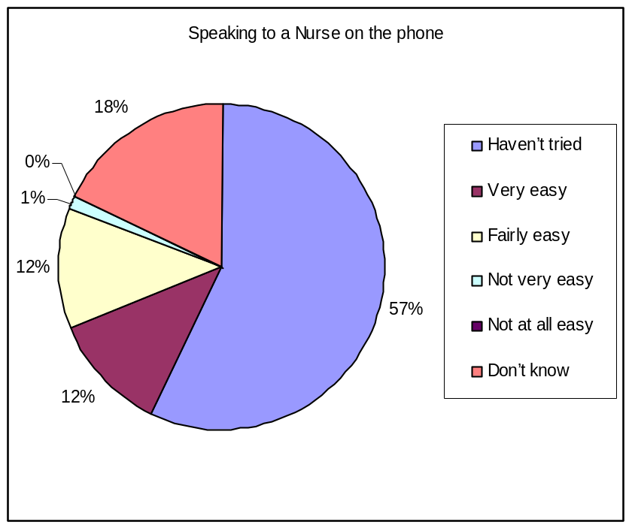

- Obtaining test results by phone
Haven’t tried 49%
Very easy 13%
Fairly easy 20%
Not very easy 1%
Not at all easy 0%
Don’t know 17%
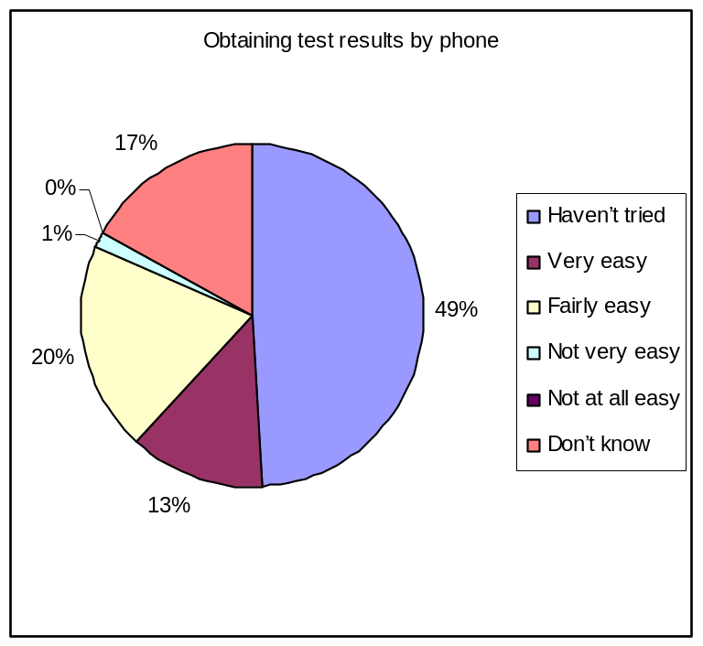

Seeing a doctor.
Q6. In the past 6 months have you tried to see a Doctor fairly quickly?
Yes 74%
No 26%
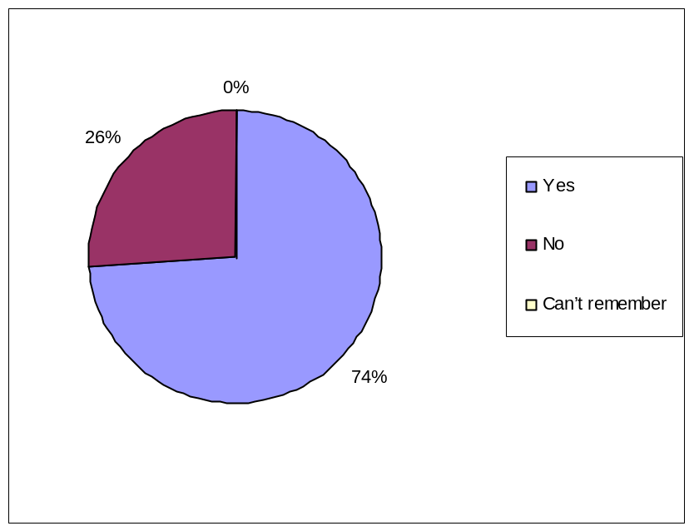 Can’t remember 0%

Q7. Thinking about the last time you tried to see a doctor fairly quickly – were you able to see a doctor on the same day or in the next two weekdays that the GP Surgery was open?
Yes 82%
No 17%
Can’t remember 1%
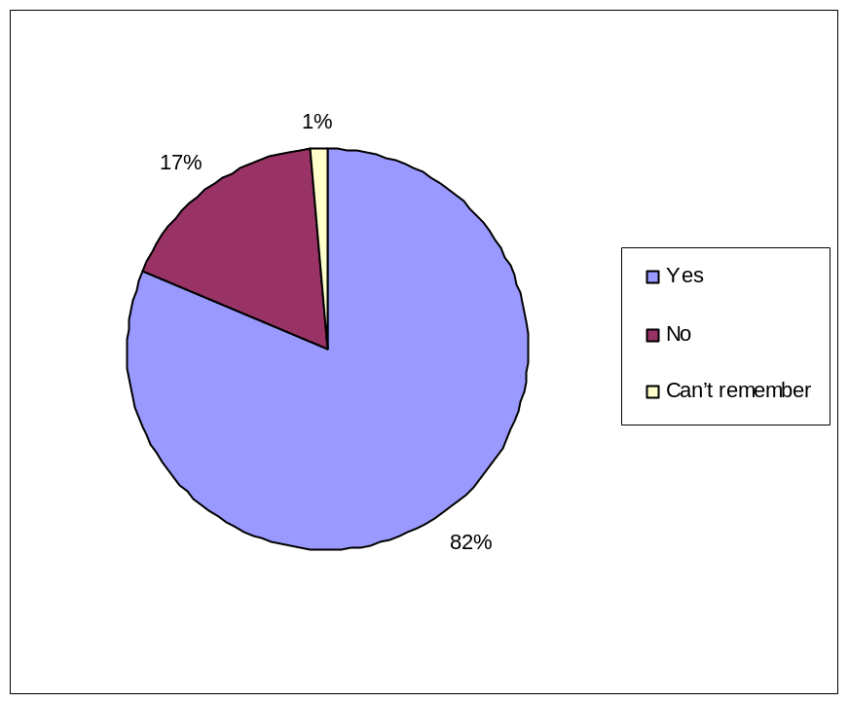

Q8. If you weren’t able to be seen during the next 2 weekdays that the GP Surgery was open, why was that?
There weren’t any appointments 14%
Times offered didn’t suit 3%
Appointment was with a Doctor who I didn’t want to see 0%
A nurse was free but I wanted to see a Doctor 0%
Another reason 0%
Can’t remember 0%
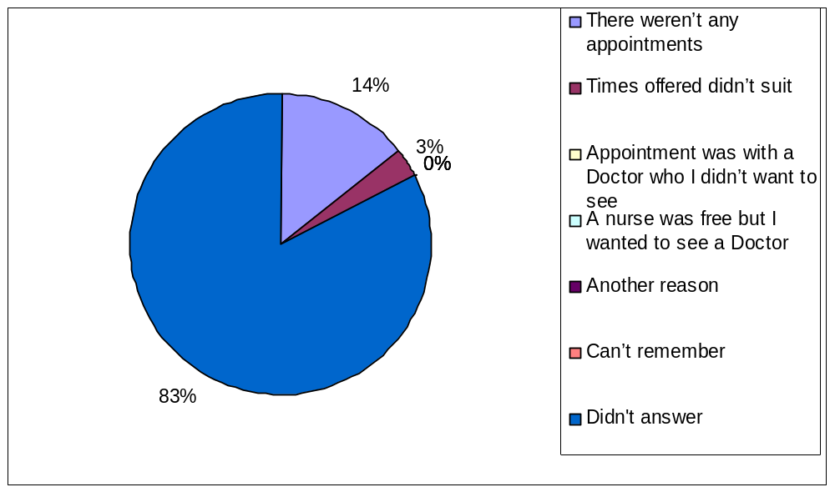Didn’t answer 83%

Q9. In the past 6 months, have you tried to book ahead for an appointment with a Doctor?
Yes 74%
No 25%
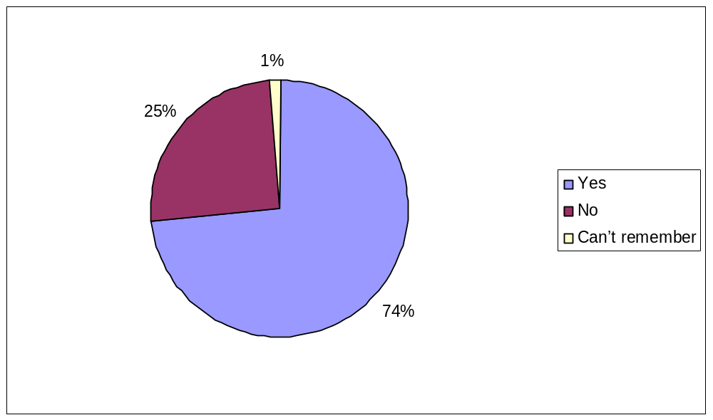 Can’t remember 1%

Q10. Last time you tried, were you able to get an appointment with a Doctor more than 2 weekdays in advance?
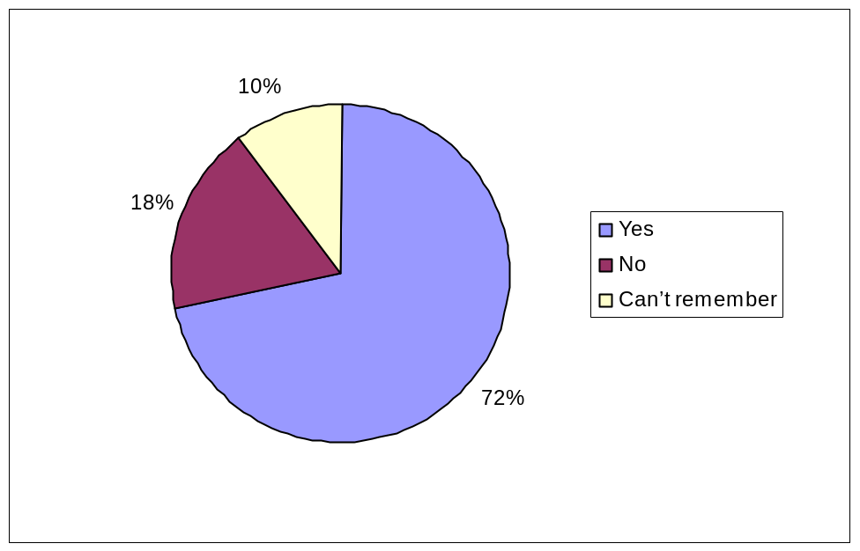 Yes 72%
No 18%
Can’t remember 10%

Arriving for your appointment.
Q11. How easy do you find getting into the building at the surgery?
Very easy 81%
Fairly easy 16%
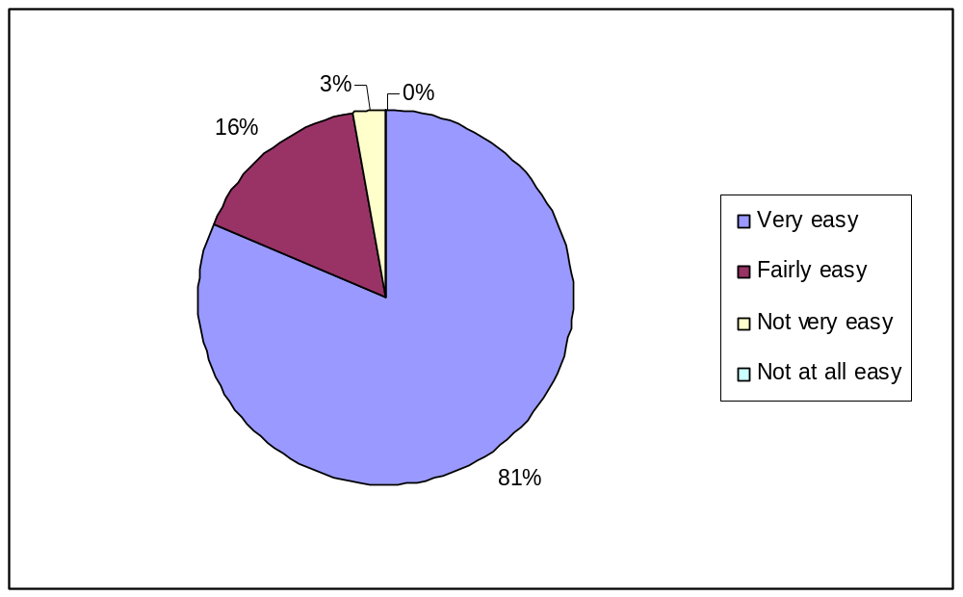
Not very easy 3%
Not at all easy 0%

Q12. How clean is the GP Surgery?
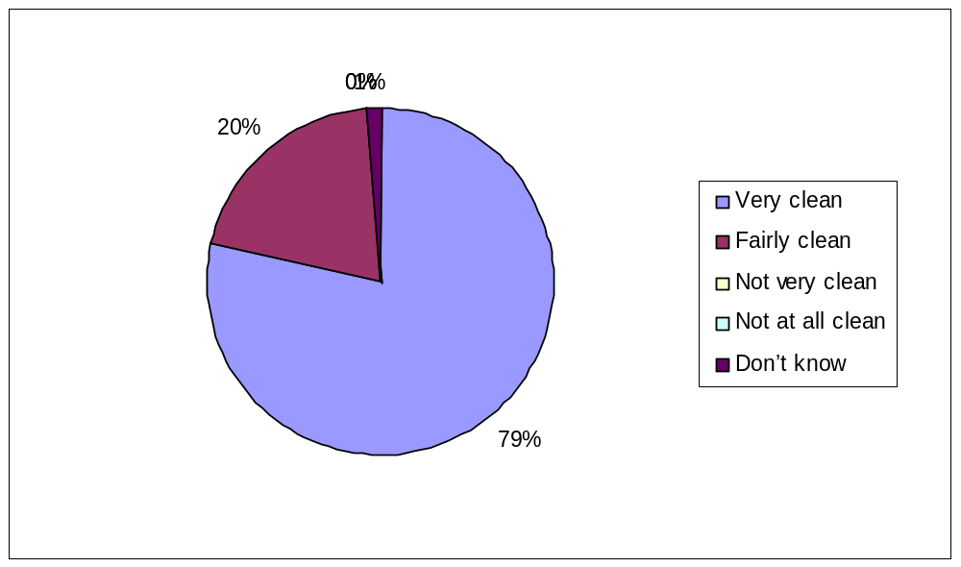 Very clean 79%
Fairly clean 20%
Not very clean 0%
Not at all clean 0%
Don’t know 1%

Q13. In the Reception Area, can other patients overhear what you say to the Receptionist?
Yes, but I don’t mind 82%
Yes, and I am not happy about it 11%
No, other patients can’t overhear 1%
Don’t know 6%
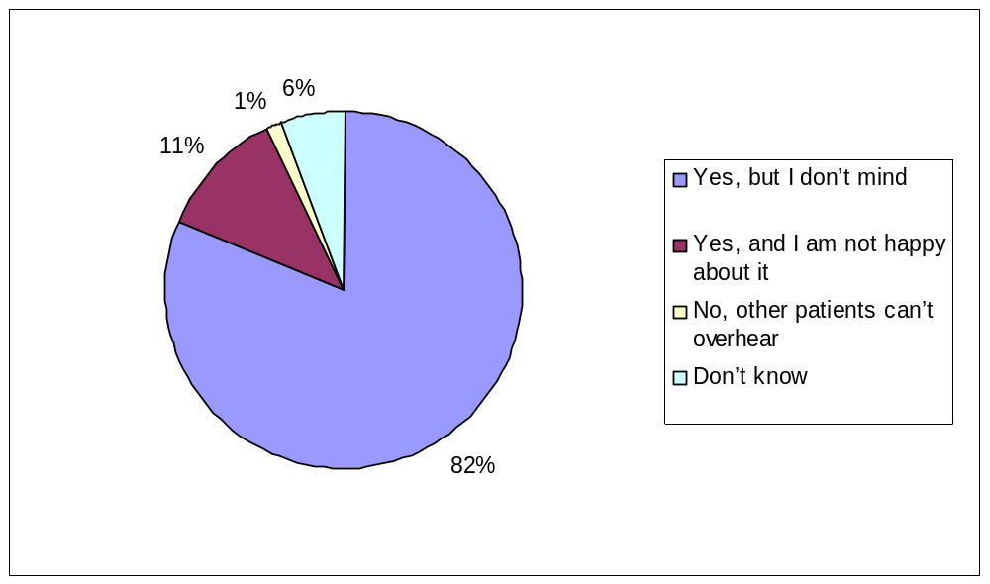

Q14. How helpful do you find the receptionists at the Surgery?
Very 67%
Fairly 33%
Not very 0%
Not at all 0%
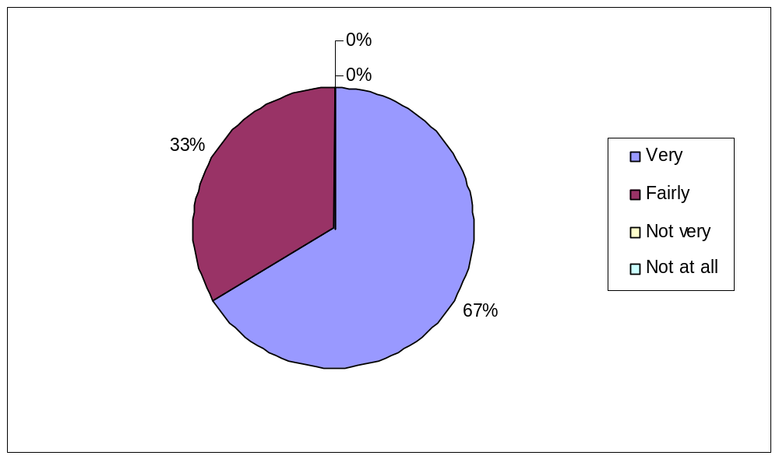

Q15. How long after your appointment time do you normally wait to be seen?
I don’t normally have appointments at a specific time 0%
I am normally seen on time 7%
Less than 5 minutes 10%
5 to 15 minutes 45%
15 to 30 minutes 32%
More than 30 minutes 6%
Can’t remember 0%
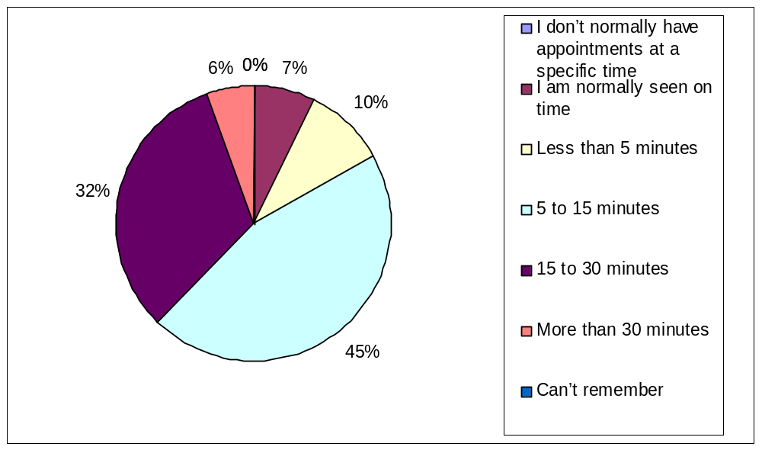

Q16. How do you feel about how long you normally have to wait?
I don’t normally have to wait long 57%
I have to wait a bit too long 17%
I have to wait far too long 6%
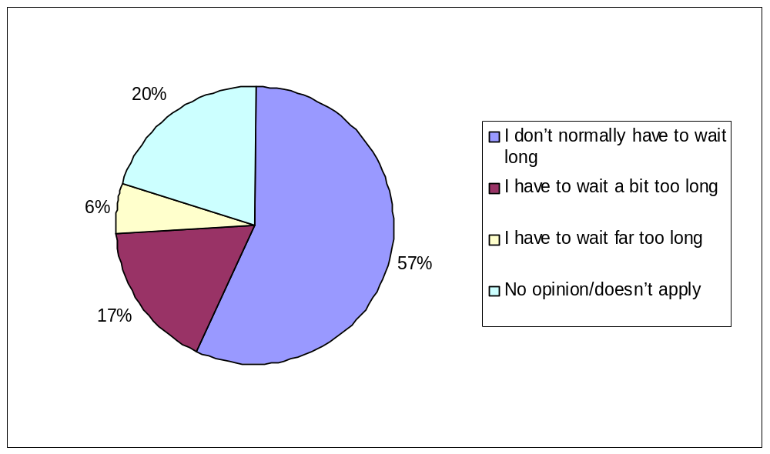 No opinion/doesn’t apply 20%

Seeing the Doctor you prefer.
Q17. Is there a particular Doctor you prefer to see at the GP Surgery?
Yes 72%
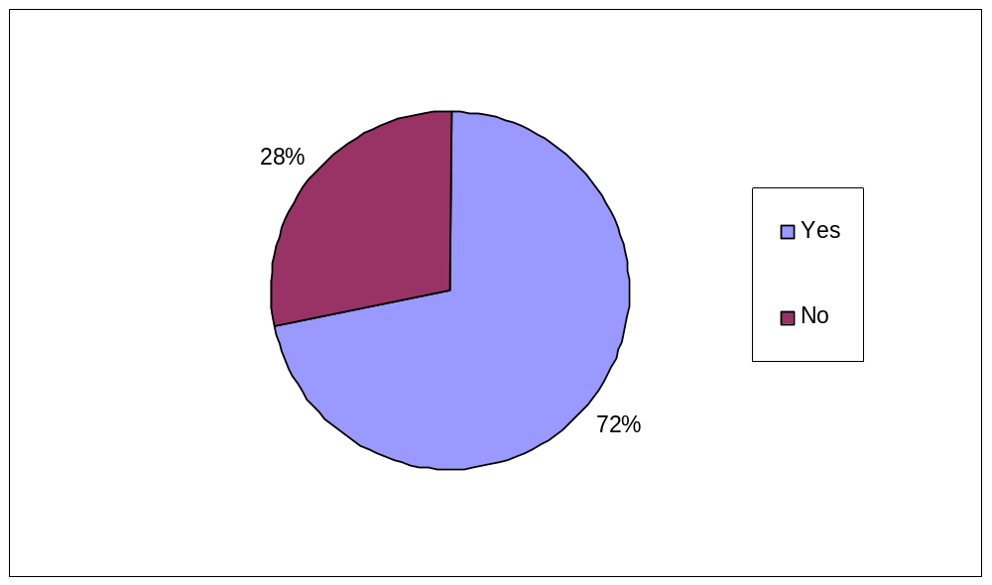 No 28%

Q18. How often do you see the Doctor you prefer?
Always or most of the time 74%
A lot of the time 12%
Some of the time 13%
Never or almost never 1%
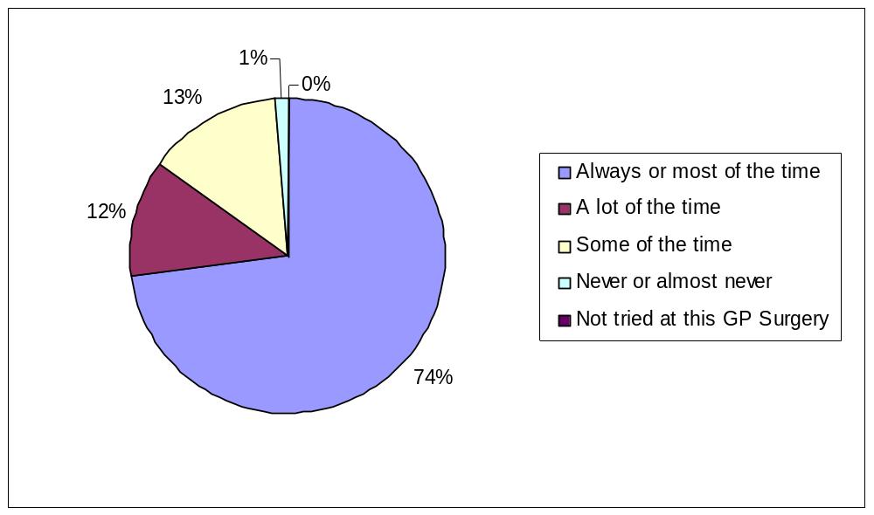 Not tried at this GP Surgery 0%

Opening Hours
Q19. How satisfied are you with the opening hours at the surgery?
Very 55%
Fairly 30%
Neither satisfied or dissatisfied 11%
Quite dissatisfied 3%
Very dissatisfied 0%
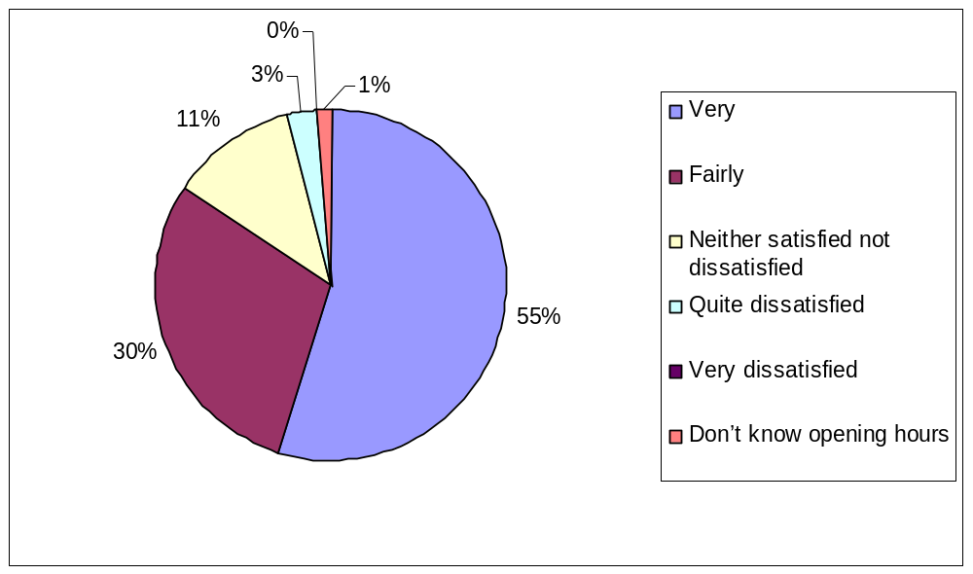 Don’t know opening hours 1%

Seeing a Doctor at the GP Surgery.
Q20. The last time you saw a Doctor at the surgery how good was the Doctor at each of the following?
- Giving you enough time
Very Good 73%
Good 24%
Neither good nor poor 3%
Poor 0%
Very poor 0%
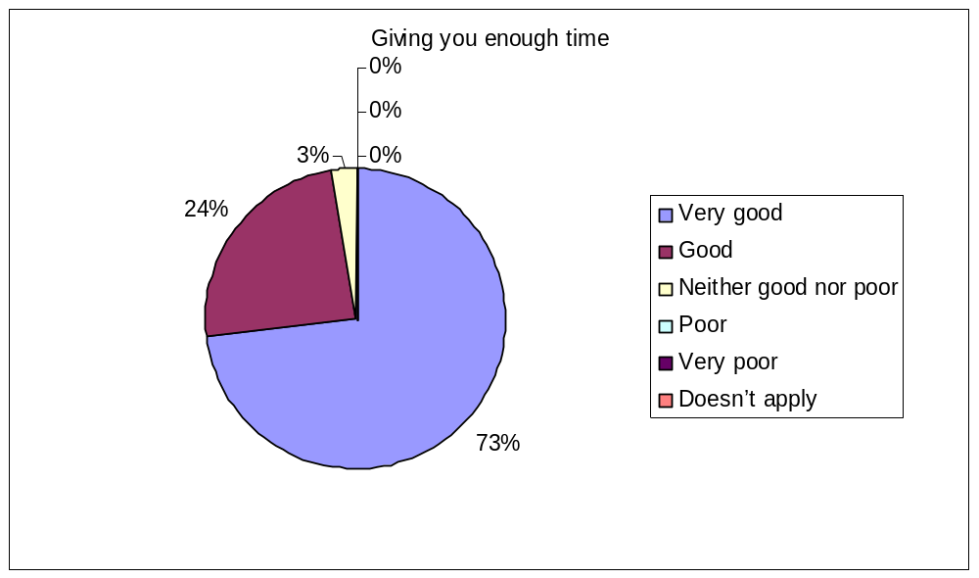Doesn’t apply 0%

- Asking about your symptoms
Very good 72%
Good 27%
Neither good nor poor 0%
Poor 1%
Very poor 0%
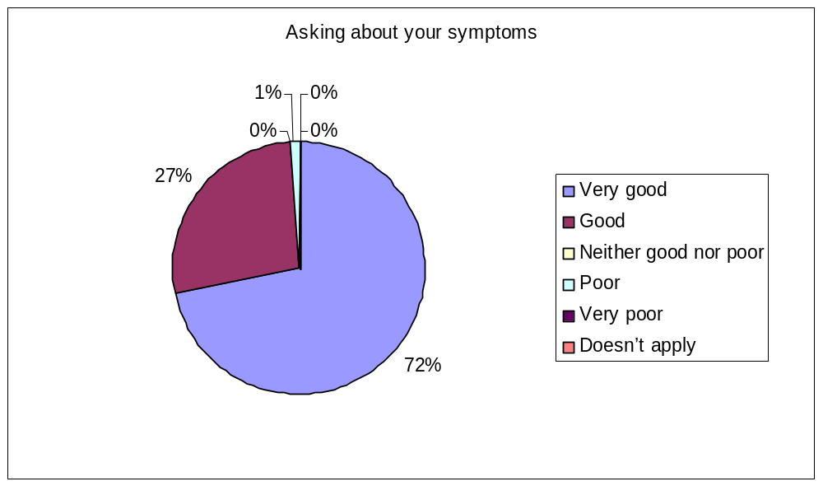Doesn’t apply 0%

- Listening
Very good 76%
Good 23%
Neither good nor poor 0%
Poor 1%
Very poor 0%
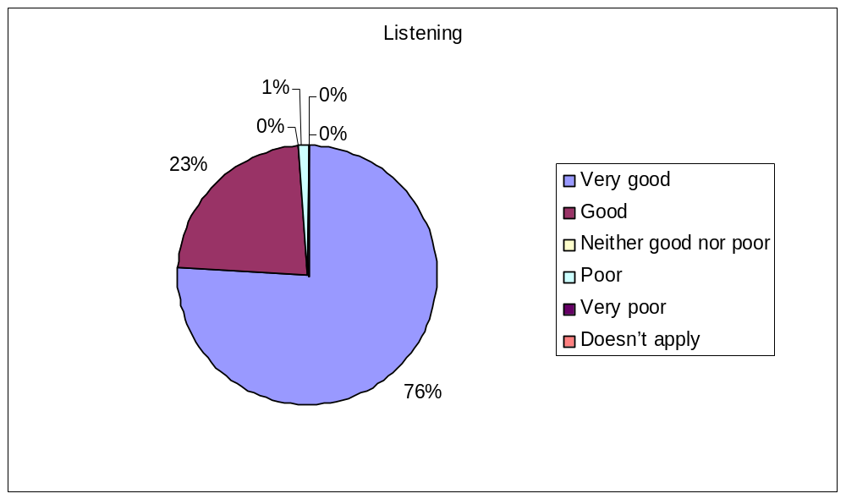Doesn’t apply 0%

- Explaining tests and treatments
Very good 75%
Good 18%
Neither good nor poor 4%
Poor 0%
Very poor 0%
Doesn’t apply 3%

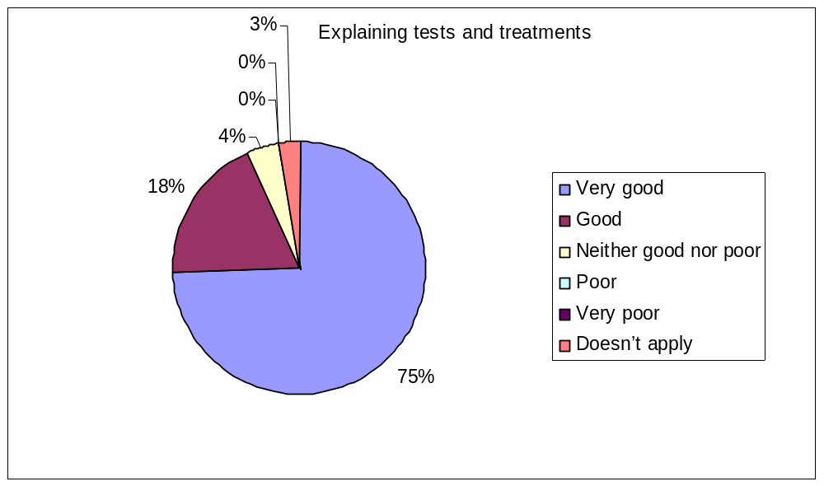

- Involving you in decisions about your care
Very good 69%
Good 13%
Neither good nor poor 6%
Poor 1%
Very poor 0%
Doesn’t apply 11%
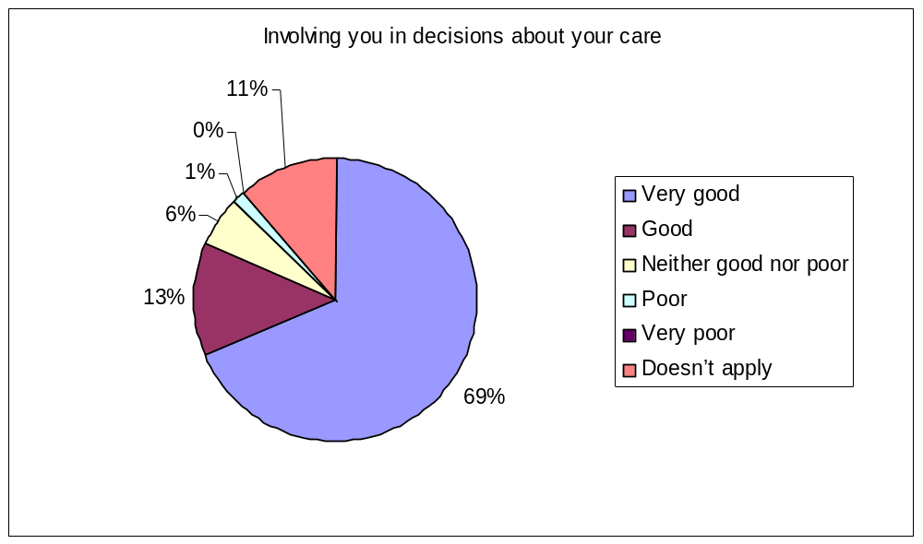

- Treating you with care and concern
Very good 72%
Good 25%
Neither good nor poor 3%
Poor 0%
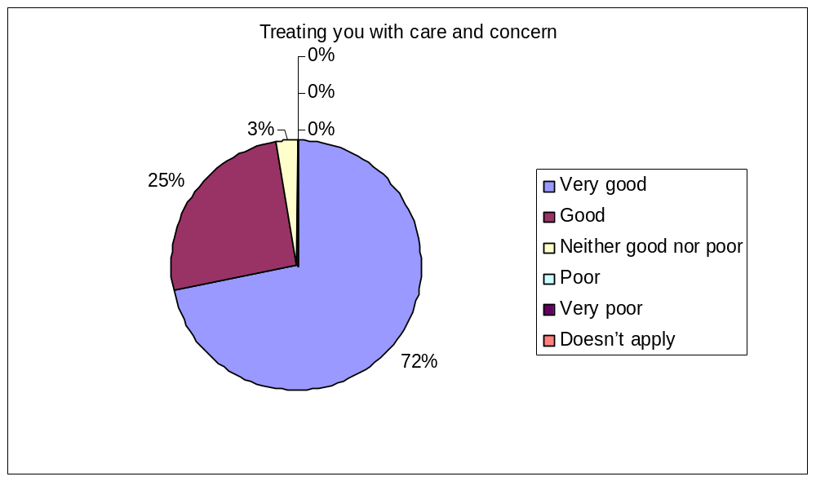Very poor 0%
Doesn’t apply 0%

- Taking your problems seriously
Very good 76%
Good 22%
Neither good nor poor 1%
Poor 1%
Very poor 0%
Doesn’t apply 0%

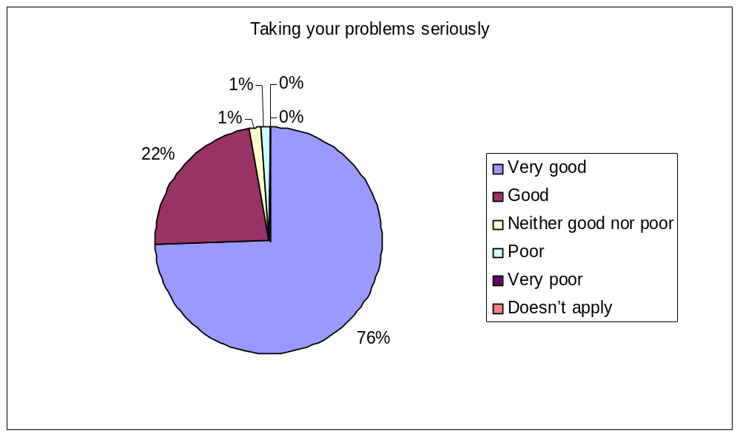

Q21. Did you have the confidence and trust in the doctor you saw?
Yes, definitely 89%
Yes, to some extent 10%
No, not at all 1%
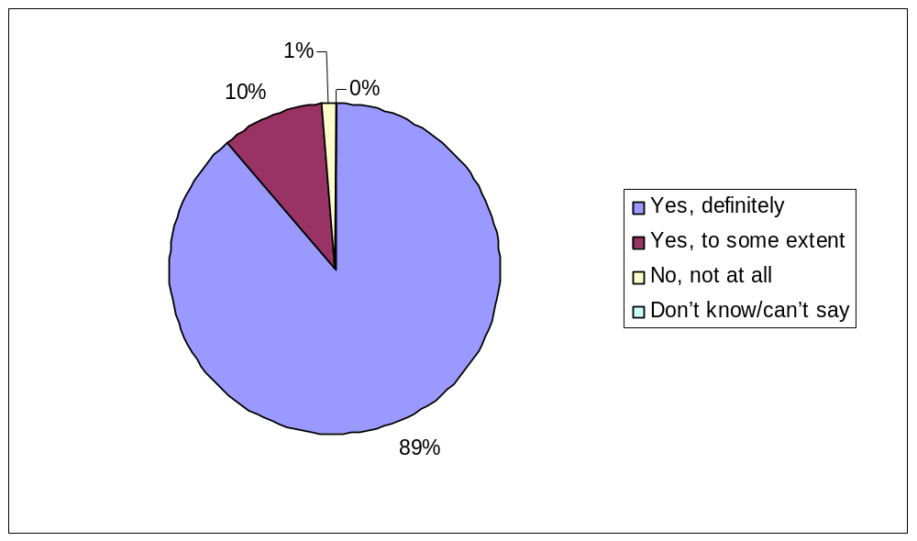 Don’t know/can’t say 0%

Seeing a Practice Nurse at the GP Surgery.
Q.22 How easy is it for you to get an appointment with a Practice Nurse at the Surgery?
Haven’t tried 7%
Very 66%
Fairly 23%
Not very 0%
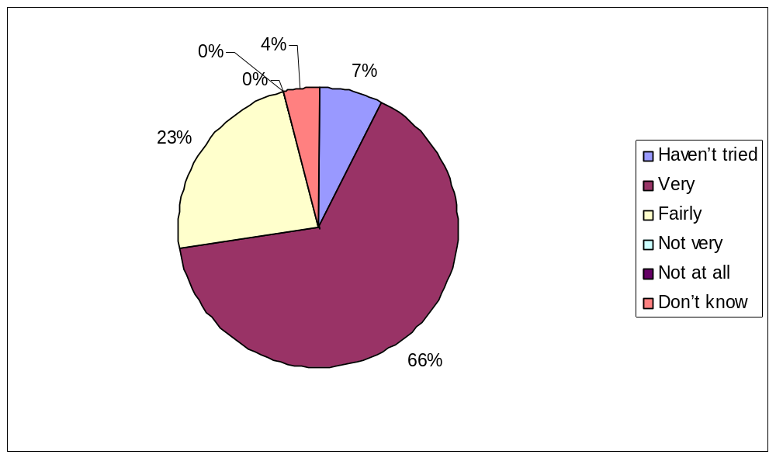 Not at all 0%
Don’t know 4%

Q23. Last time you saw a Practice Nurse at the Surgery, how good did you find the Practice Nurse at each of the following?
- Giving you enough time
Very good 81%
Good 12%
Neither good nor poor 0%
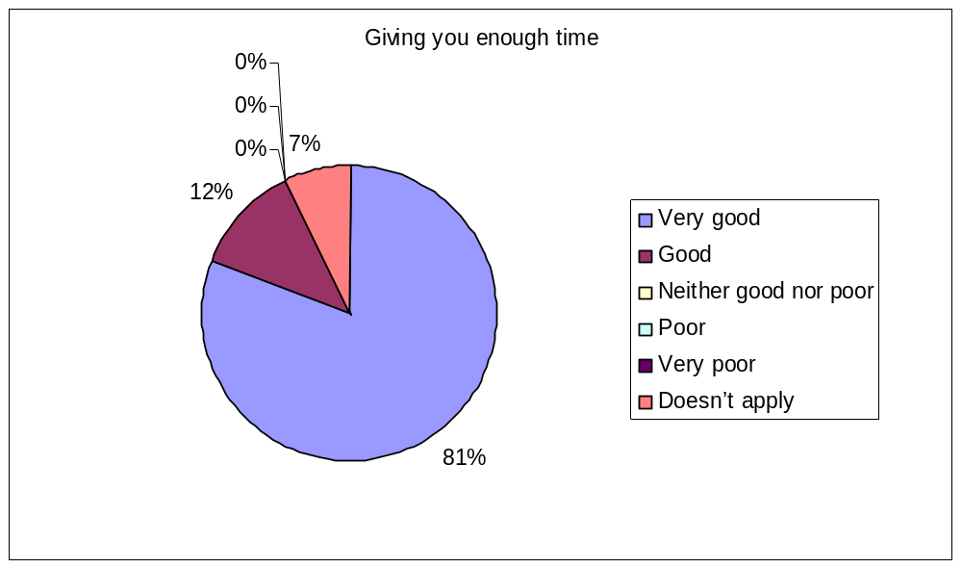Poor 0%
Very poor 0%
Doesn’t apply 7%

- Asking about your symptoms
Very good 61%
Good 10%
Neither good nor poor 1%
Poor 0%
Very poor 0%
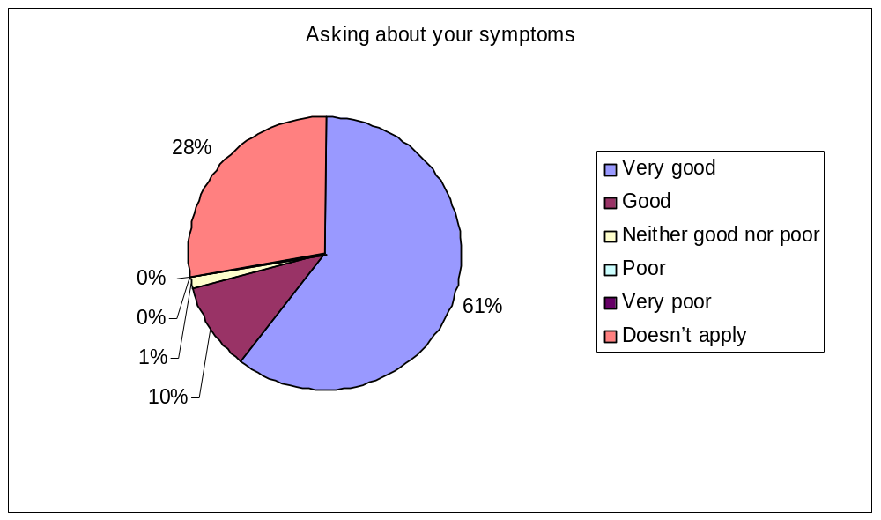Doesn’t apply 28%

- Listening
Very good 75%
Good 11%
Neither good nor poor 3%
Poor 0%
Very poor 0%
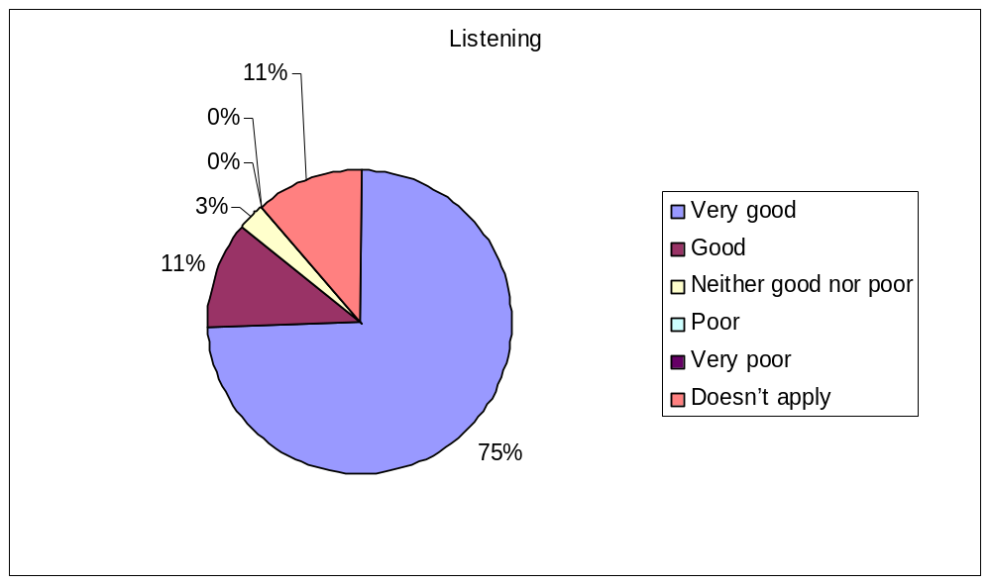Doesn’t apply 11%

- Explaining tests and treatments
Very good 66%
Good 16%
Neither good nor poor 1%
Poor 0%
Very poor 0%
Doesn’t apply 17%

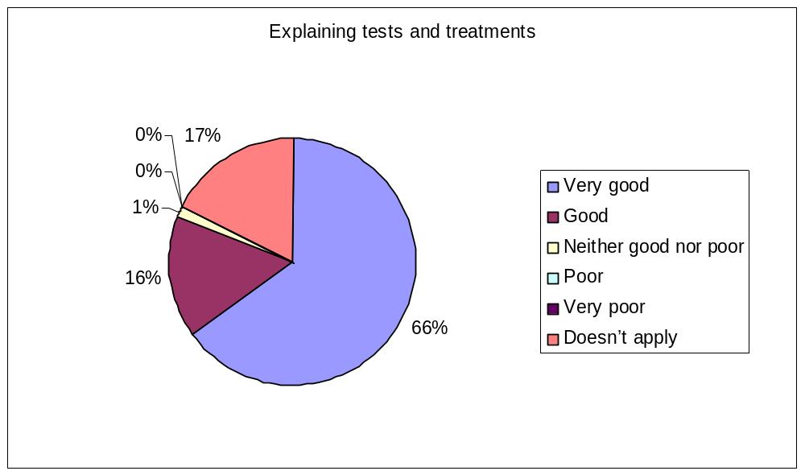

- Involving you in decisions about your care
Very good 47%
Good 4%
Neither good nor poor 3%
Poor 0%
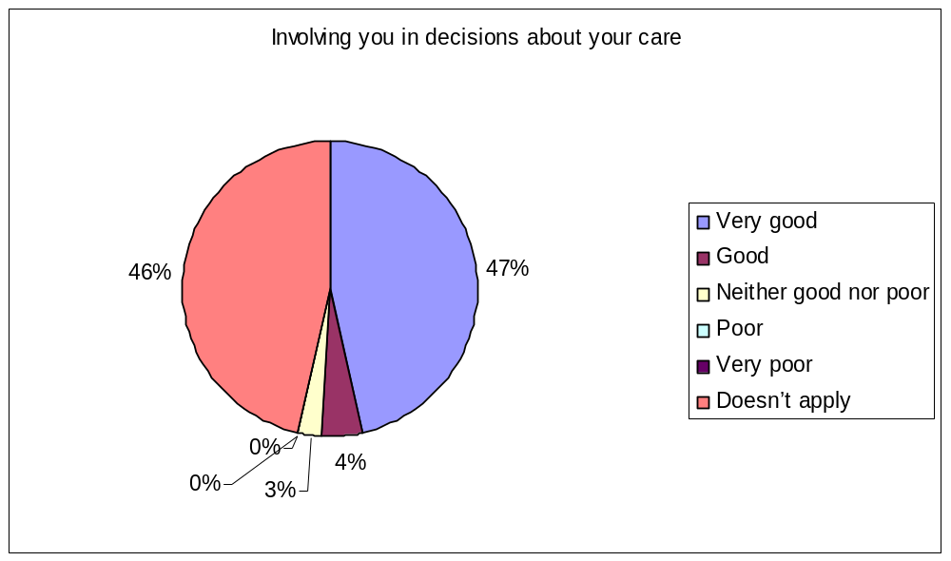Very poor 0%
Doesn’t apply 46%

- Treating you with care and concern
Very good 78%
Good 12%
Neither good nor poor 0%
Poor 0%
Very poor 0%
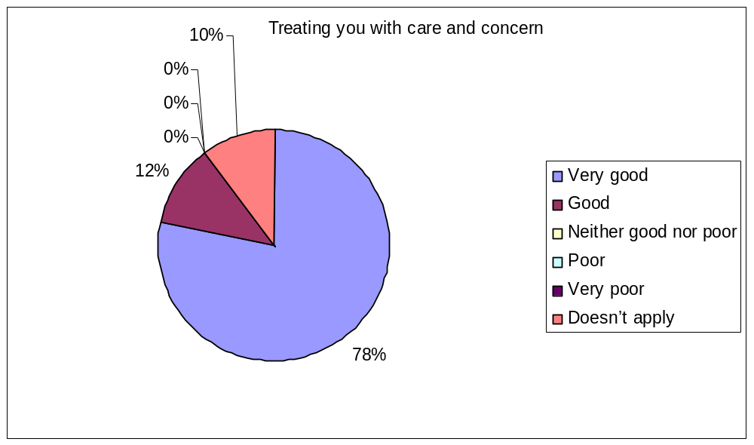Doesn’t apply 10%

- Taken your problems seriously
Very good 67%
Good 7%
Neither good nor poor 1%
Poor 0%
Very poor 0%
Doesn’t apply 25%

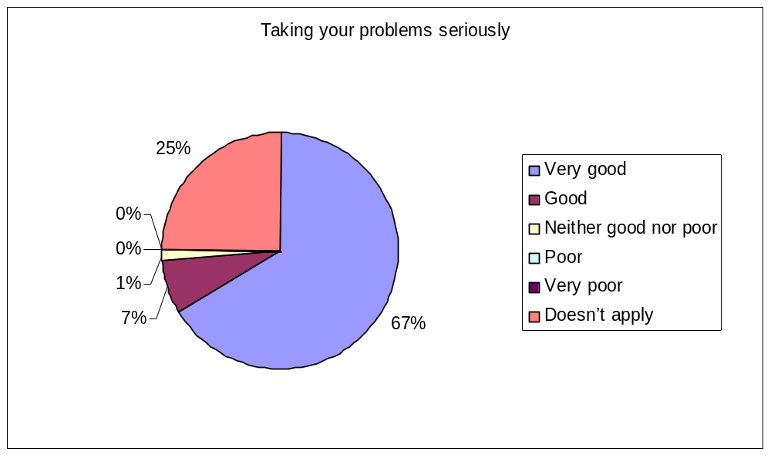

Your overall satisfaction.
Q24. In general, how satisfied are you with the care you get at the Surgery?
Very 86%
Fairly 13%
Neither satisfied nor dissatisfied 1%
Quite dissatisfied 0%
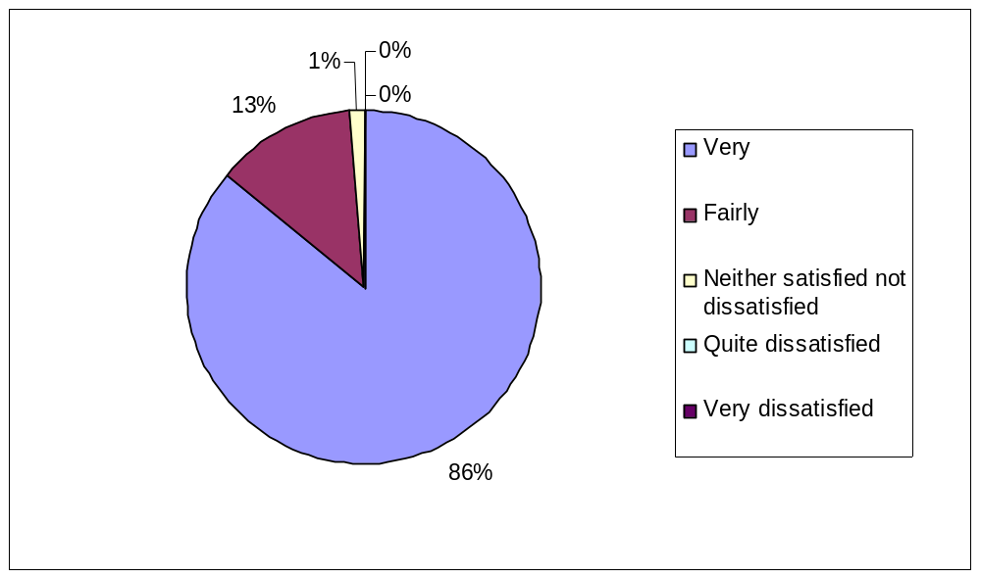 Very dissatisfied 0%

Q25. Would you recommend the Surgery to someone who has just moved to your local area?
Yes 91%
Might 7%
Not sure 1%
Probably not 1%
Definitely not 0%
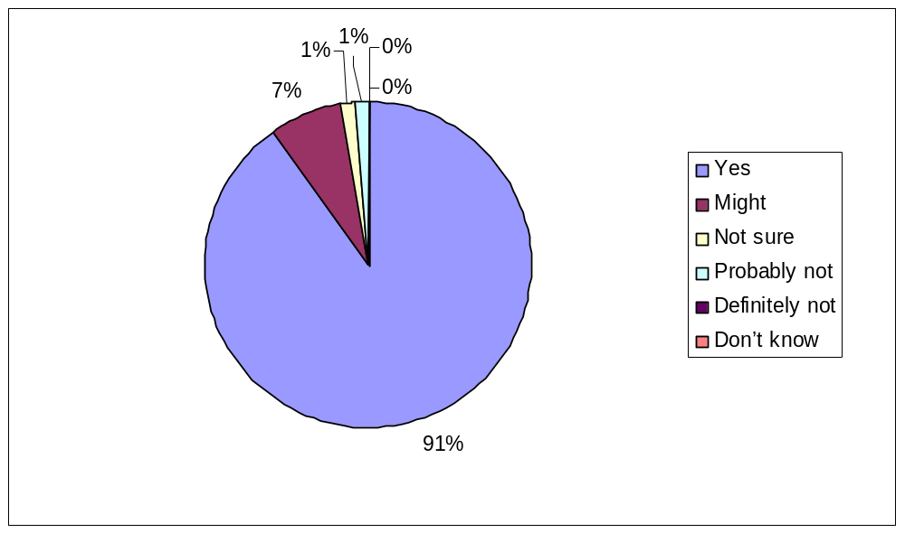 Don’t know 0%

Planning your care.
Q26. Do you have any long-standing health problems, disability or infirmity? Please include anything that has troubled you over a period of time or that is likely to affect you over a period of time?
Yes 70%
No 26%
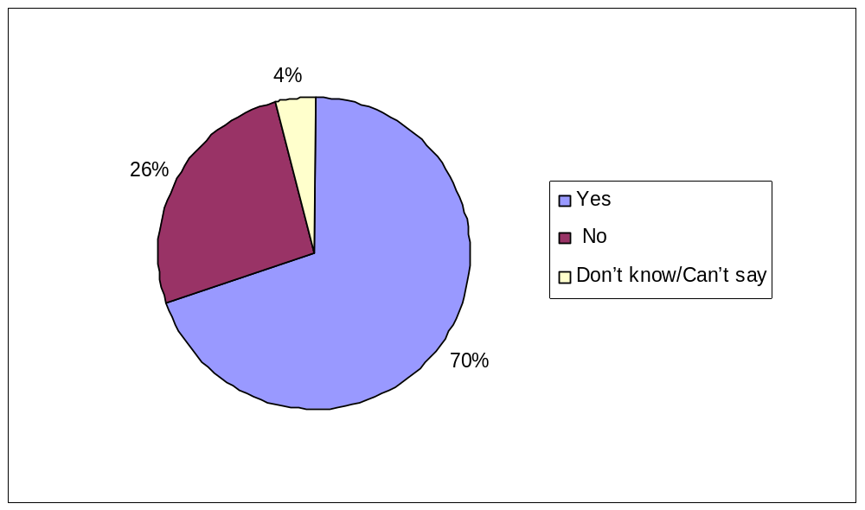 Don’t know/Can’t say 4%

Q27. Have you had discussions in the past 12 months with a Doctor or Nurse about how best to deal with your health problems?
Yes 96%
No 8%

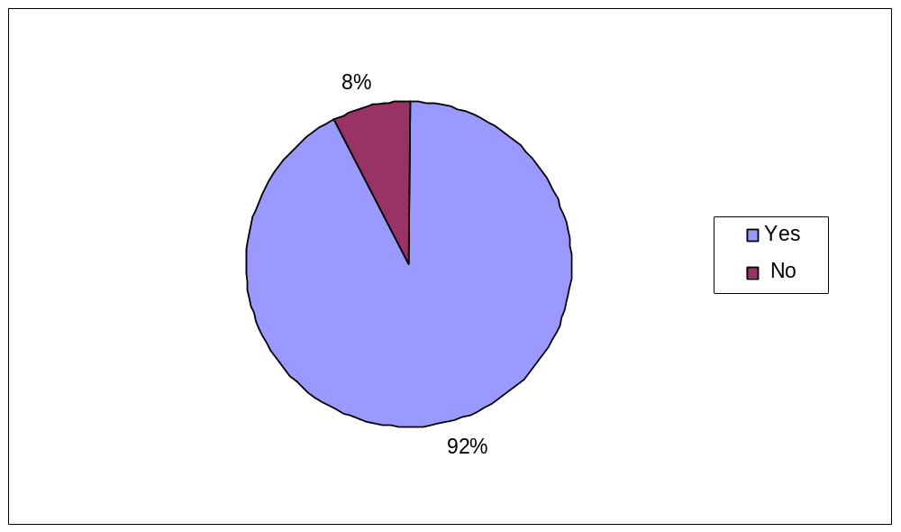

Q28. In these discussions…
- Did the doctor or nurse take notice of your views about how to deal with your health problem?
Yes 92%
No 2%
Don’t know 2%
N/A 4%
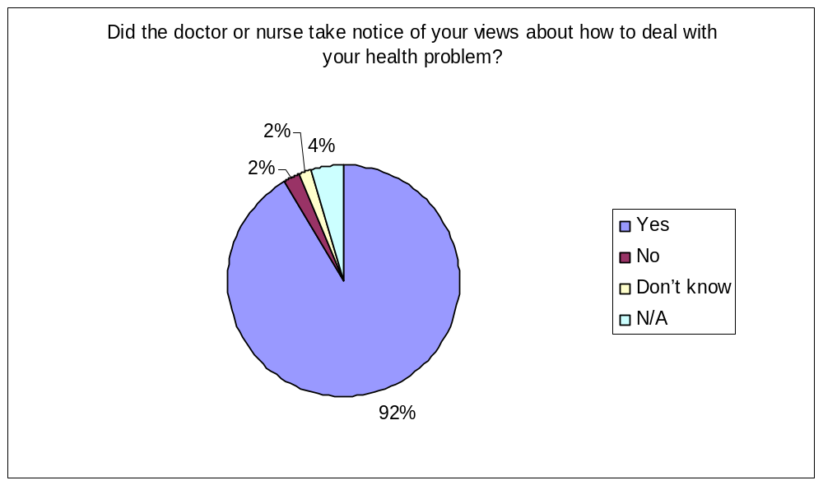

- Did the doctor or nurse give you information about the things you might do to deal with your health problem?
Yes 87%
No 9%
Don’t know 2%
N/A 2%

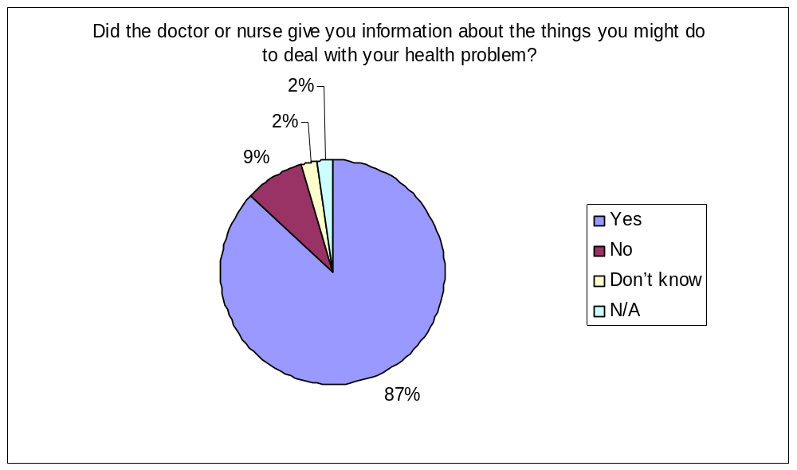

- Did you and the doctor or nurse agree how best to manage your health problem?
Yes 84%
No 7%
Don’t know 0%
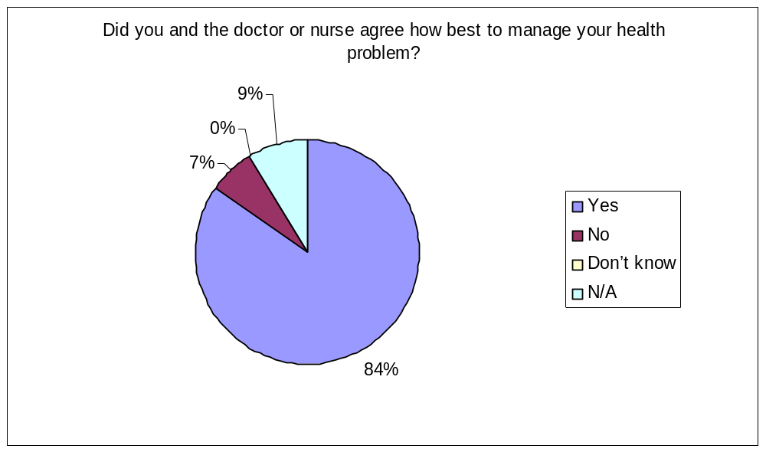N/A 9%

- Did the doctor or nurse give you a written document about the discussions you had about managing your health problem?
Yes 17%
No 68%
Don’t know 0%
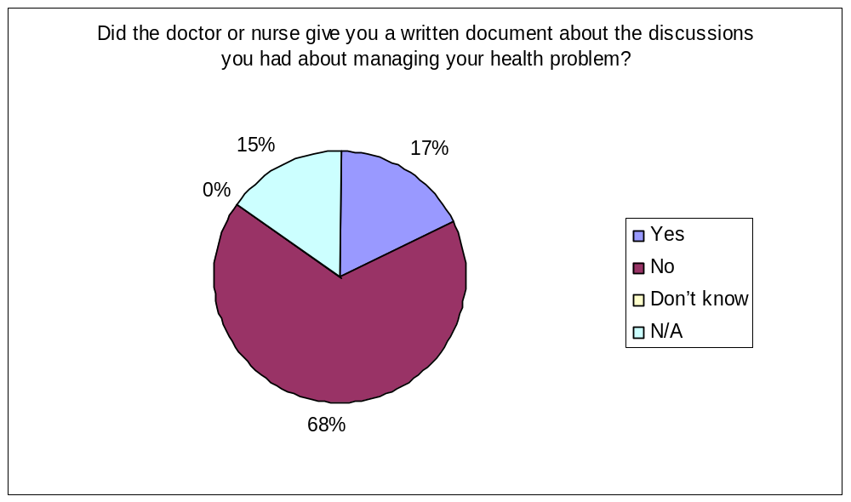N/A 15%

- Would you have liked a written plan summarising your discussion with the doctor or nurse?
Yes 9%
No 54%
Don’t know 24%
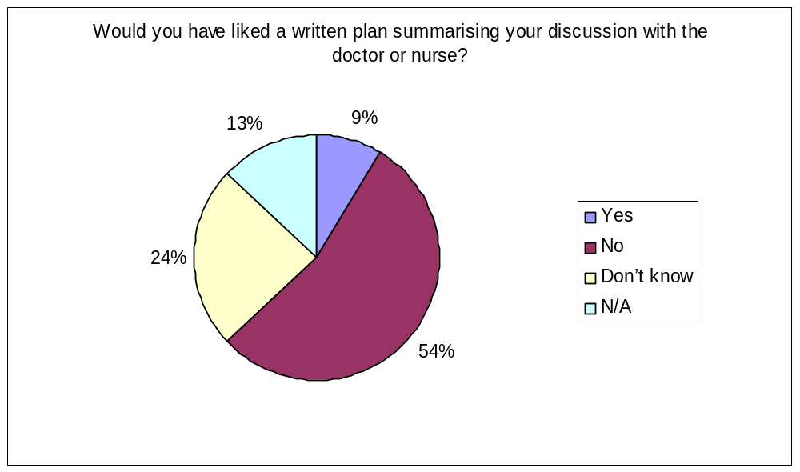N/A 13%

- Did the doctor or nurse mention that you had something called a care plan?
Yes 9%
No 69%
Don’t know 2%
N/A 20%

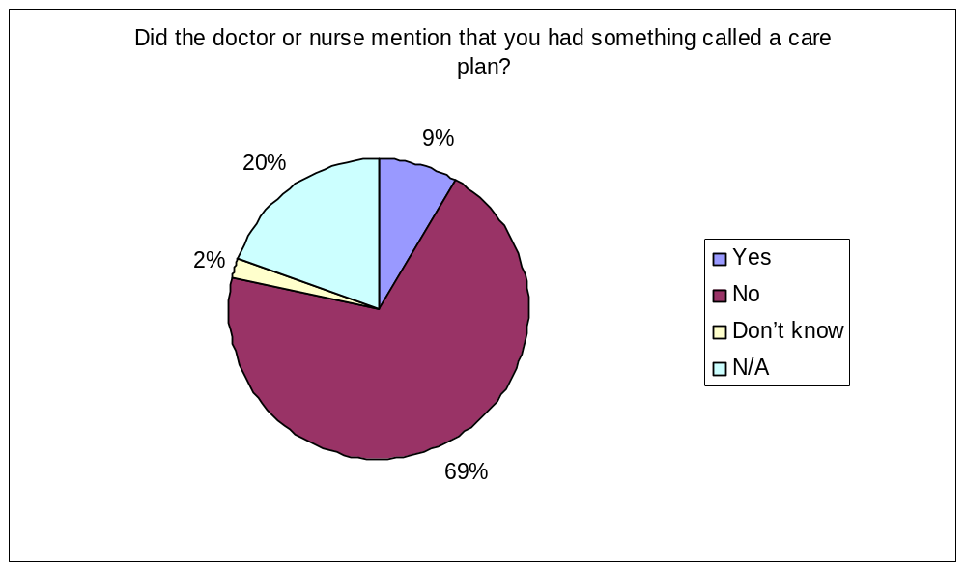

Q29. Do you think that having these discussions with your doctor or nurse has helped improve how you manage your health problems?
Yes 60%
To some extent 38%
Don’t know/can’t remember 2%
Very dissatisfied 0%
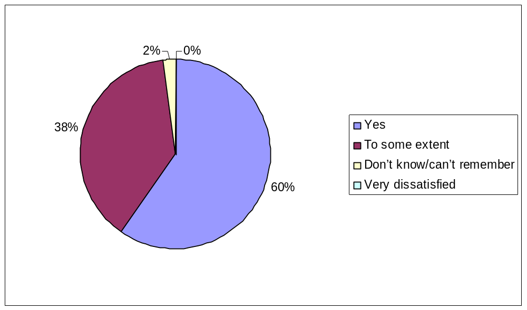

Some questions about you.
Q30. Are you male or female?
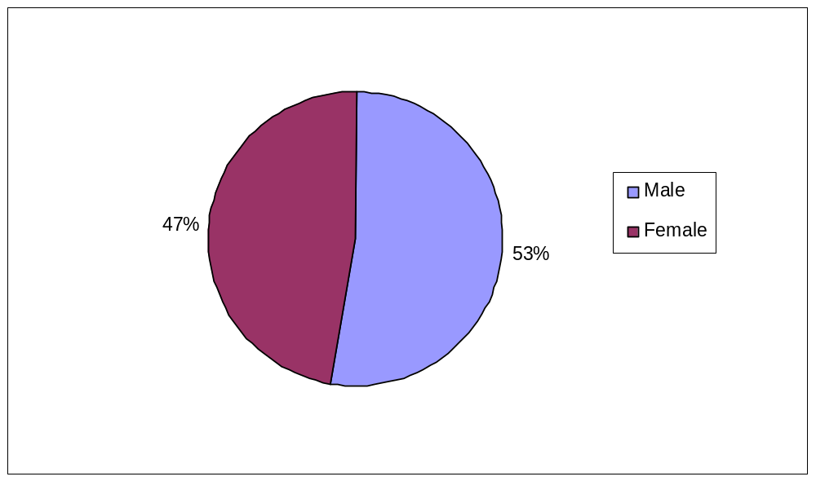 Male 53%
Female 47%

Q31. How old are you?
Under 18 0%
  - 1%
  - 3%
  - 7%
  - 24%
  - 19%
  - 23%
  - 19%
85 and over 4%
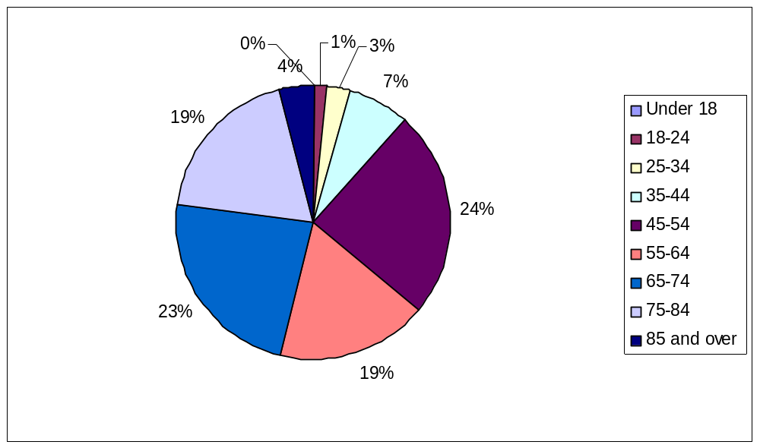

Q32. Which one of these best describes what you are doing at present?
Full-time paid work (30hours or more per week) 24%
Part-time paid work (under 30hours per week) 14%
Full-time education (school, college, university) 0%
Unemployed 3%
Permanently sick or disabled 1%
Fully retired from work 47%
Looking after the home 11%
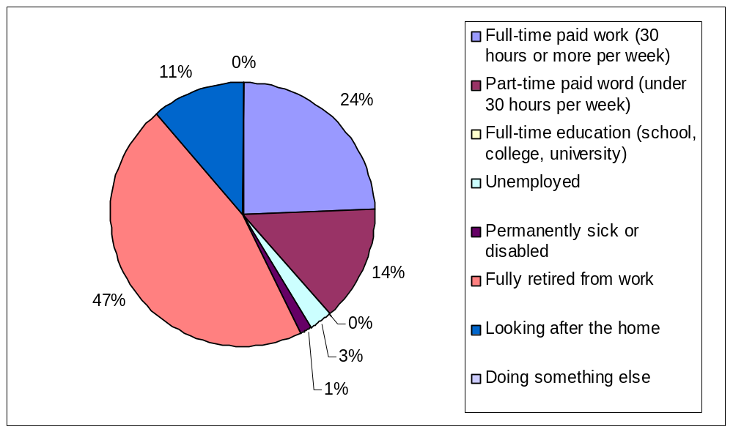 Doing something else 0%

Q33. In general, would you say that your health is …
Excellent 12%
Very good 27%
Good 43%
Fair 12%
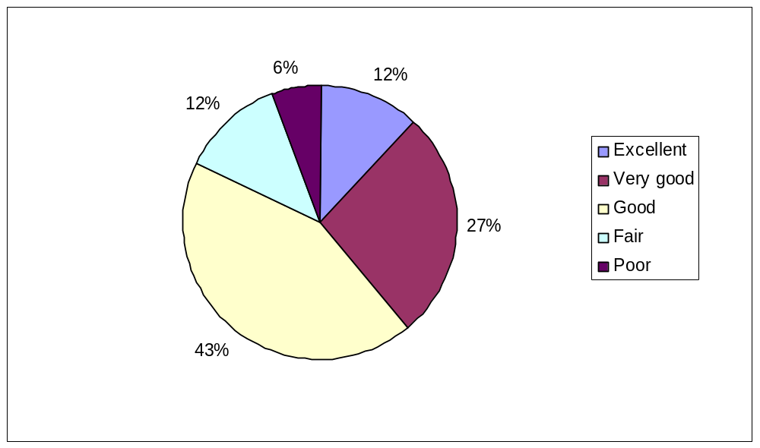 Poor 6%

Q34. Do you have any of the following conditions? Please include problems due to old age.
Blindness or sever visual impairment 0%
A condition that substantially limits one of more basic physical activities, such as walking, climbing stairs, lifting or carrying 24%
Learning difficulty 0%
A long-standing psychological or emotional condition 3%
Other, including any long-standing illness 33%
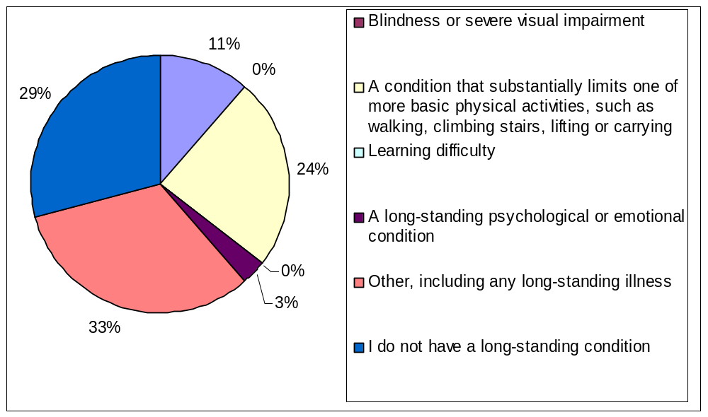I do not have a long-standing condition 29%

Q35. Are you a deaf person who uses sign language?
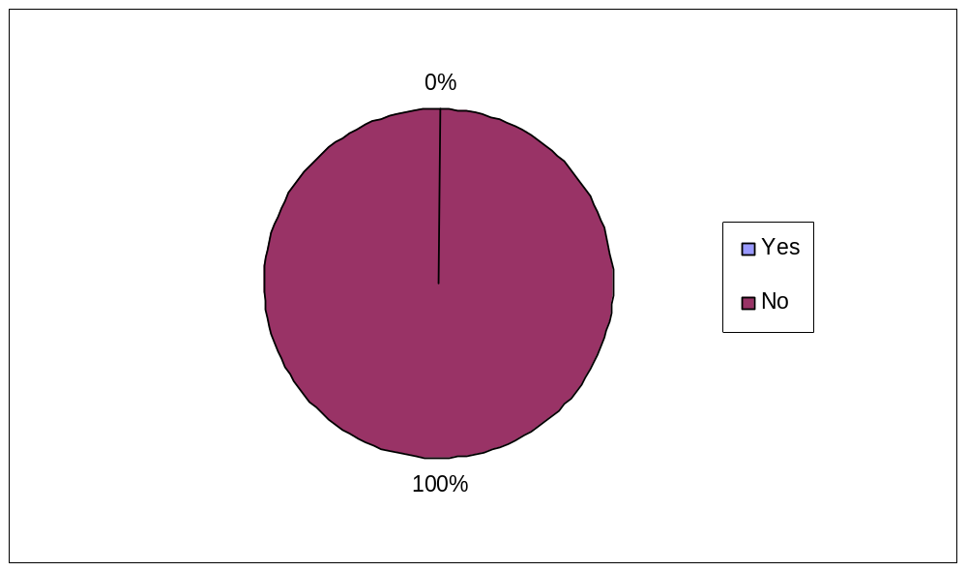 Yes 0%
No 100%

Q36. Are you a parent or a legal guardian of any children aged under 16 years old currently living in your home?
Yes 88%
No 12%

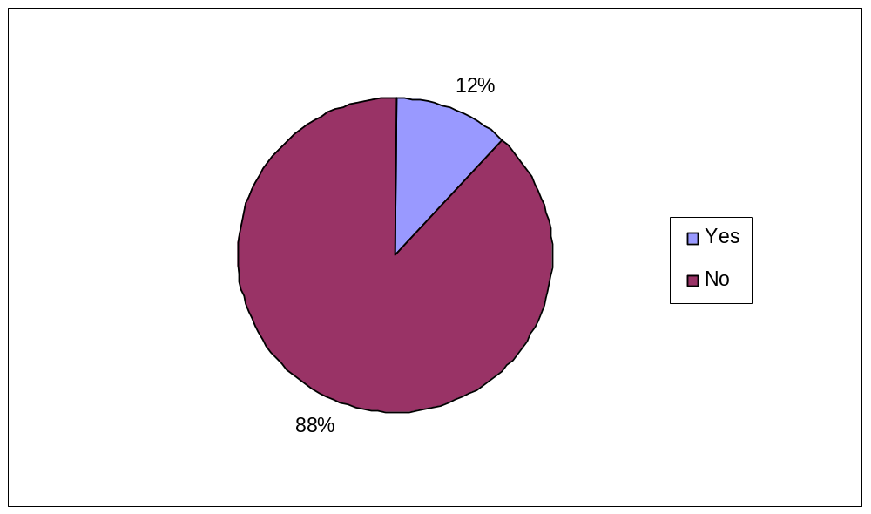

Q37. Do you have carer responsibilities for anyone in your household with a long-standing heart problem or disability?
Yes 17%
No 83%



